EEE3091F

Induction Motor Project Report

Ankush Chohan – CHHANK001

Ashik John - JHNASH009

03/04/2023

**Plagiarism Declaration**

We hereby declare that the content presented in this project report is entirely our own work, unless otherwise cited or referenced. We understand that plagiarism is a serious academic offense and that using another person's work without proper attribution is considered to be dishonest and unethical.

To the best of our knowledge, all the ideas, words, and images used in this report are our own. We understand that if any part of this work is found to be plagiarized, we may face serious consequences, including a failing grade or other disciplinary actions.

Signed:

Ankush Chohan (CHHANK001) Ashik John (JHNASH009)

Date: 03/04/2023

**Part A – Matlab Code**

|  |  |  |
| --- | --- | --- |
|  | **SE Motor** | **EE Motor** |
| **Vth** | 206.07 V | 208.82 V |
| **Rth** | 1.84 Ω | 1.36 Ω |
| **Xth** | 4.07 Ω | 3.49 Ω |

1.

2.

1. SE Motor: 23.38 Nm

EE Motor: 30.6 Nm

Starting torque can either be altered by changing the rotor resistance (increasing rotor resistance increases starting torque), or by changing the supply voltage (starting torque increases as supply voltage increases).

1. SE Motor: 69.86 Nm

EE Motor: 81.30 Nm

This value can be altered by changing the supply voltage. Maximum torque is directly proportional to the square of the supply voltage.

1. SE Motor: 1260 rpm

EE Motor: 1215 rpm

The speed at which the maximum torque occurs can be altered by changing the rotor resistance, by means of adding external winding resistance. Increasing the rotor resistance decreases the speed at which the maximum torque occurs.

**Part B – Theoretical Questions**

1.

(a) Bigger motors can make use of larger copper windings in the stator and rotor. Larger windings mean less resistance, and therefore less copper losses. Less losses means greater efficiency.

(b) Underloading motors decreases the efficiency of the machine. The machines are optimised to have the highest efficiency at the rated load. Characteristics such as torque and current would not be at rated levels, decreasing efficiency.

2.

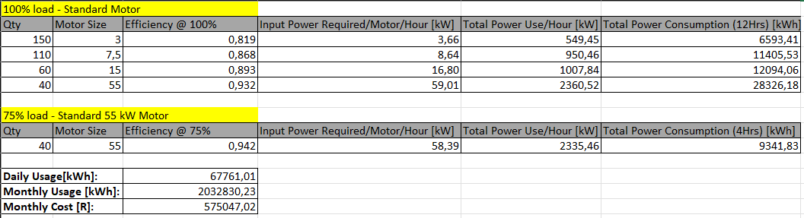(a) The following calculations were made:

From this,

Monthly usage: **2 032 830.23 kWh**

Monthly bill: **R 575 047.02**

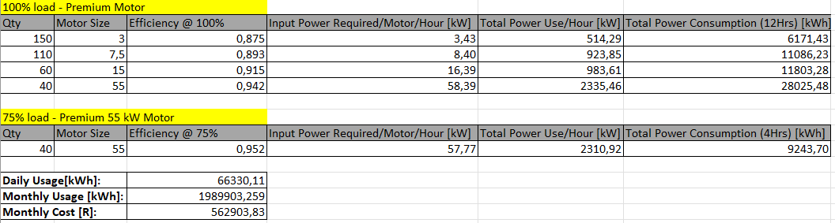(b) The following calculations were made:

From this,

Monthly usage: **1 989 903.26 kWh**

Monthly bill: **R 562 903.83**

(c) The savings from installing premium motors/month will be: **R 12 143.18**

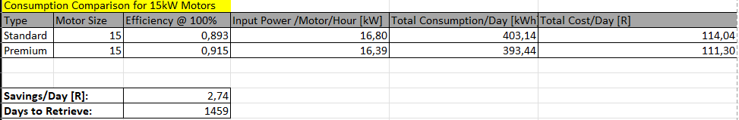3. Based on the calculations below, it would take 1459 days to retrieve the money.